**LAB 10  
Creating an AWS RDS Instance in Terraform**

**STEP 1: Create a new Directory.**



**STEP 2: Create terraform configuration file (main.tf)**

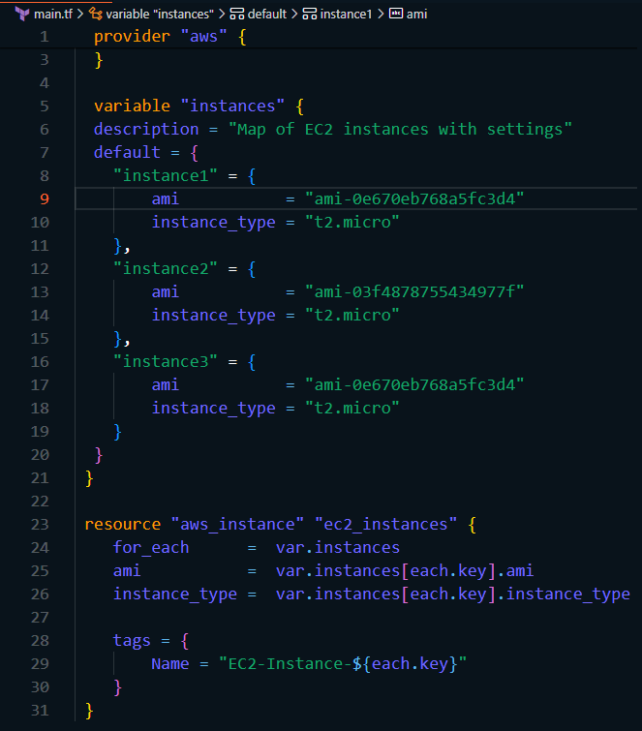

In this configuration, we define an AWS RDS instance with specific settings, such as engine type, instance class, and security group.

**STEP 3: Initialize and apply.**

* **terraform init**

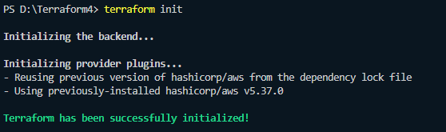

* **terraform apply**

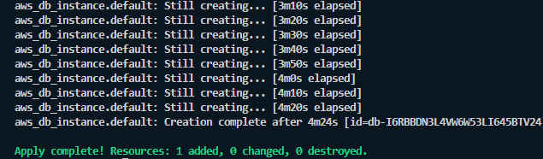

**STEP 4: Verify resources in AWS console.**

* Verify that the resources with the specified names and settings have been created.



**STEP 5: Open MySQL workbench to connect to the RDS.**

* Click on + icon which is show on homepage.



* Set up a new connection, give it a name, username and password should be same as in main.tf and inside hostname paste the endpoint of the RDS you created.

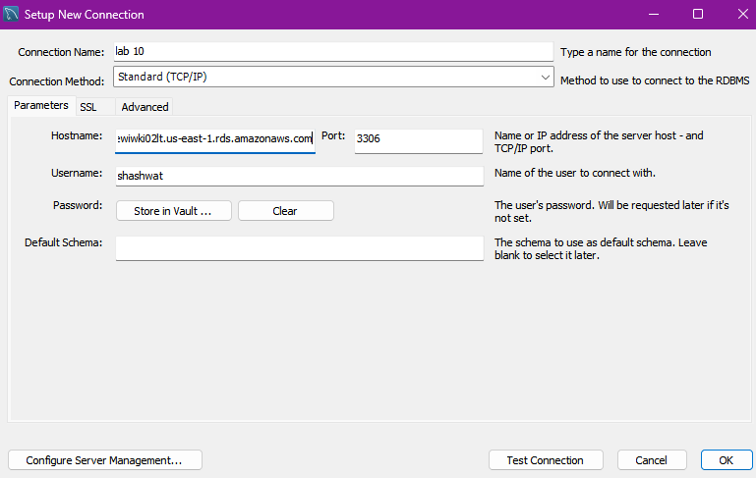

* Test the connection to see if its successful.

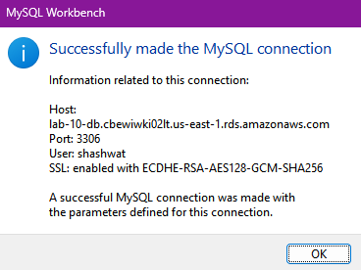

* If the connection is successful, click ok and then the RDS will be displayed on the homepage.

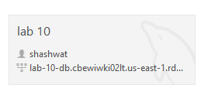

**STEP 6: Clean up.**

* After testing, we clean up the used resources by terraform destroy.

